#F8F1EA

**Higher Education in Luzon in**



#F8F1EA

**S.Y. 2016-2017, S.Y. 2017-**

**2018, and S.Y. 2018-2019**

A research of five variables to display the current situation of higher

education in Luzon for three school years.

Study Background

#533220

Study Background

This study aims to display the current situation of higher education in the Luzon Island, the major educational hub of the



#F8F1EA

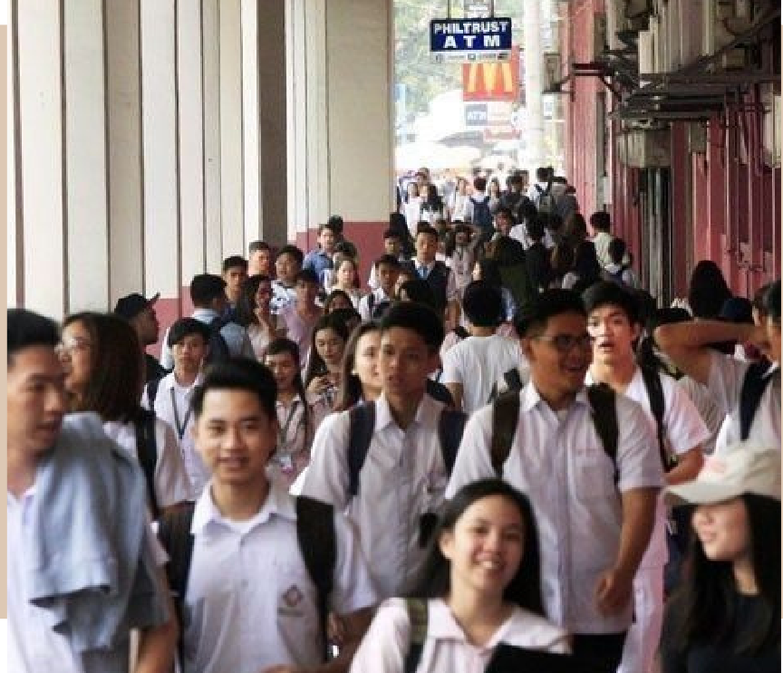

Image

Philippines, through:

checking whether all the colleges in Luzon are still within the range of the recommended faculty-to-student ratio; and

monitoring the progress of the colleges in Luzon for the S.Y. 2016-2017, S.Y. 2017-2018, and

S.Y. 2018-2019 through its student and faculty

population.

Main Content

#533220

# Number of Students

Data

#F8F1EA

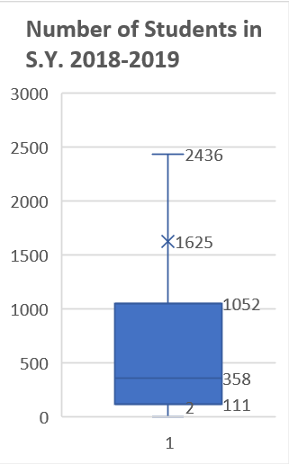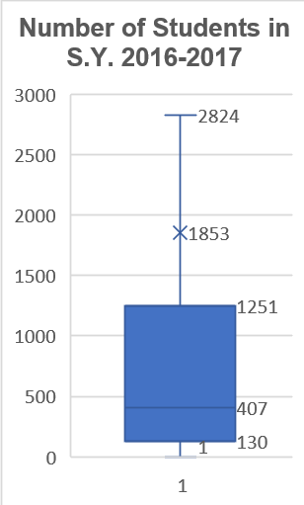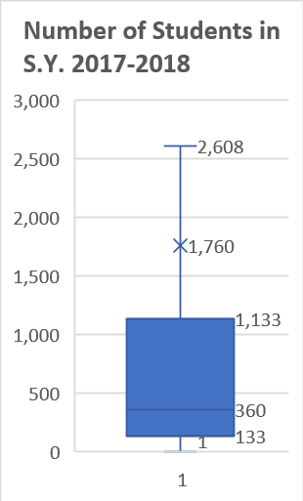

# Number of Students

#F8F1EA

#533220

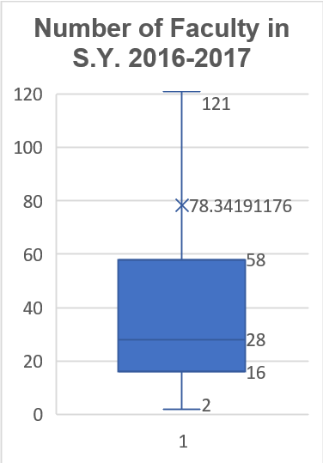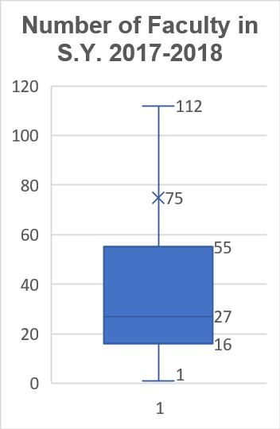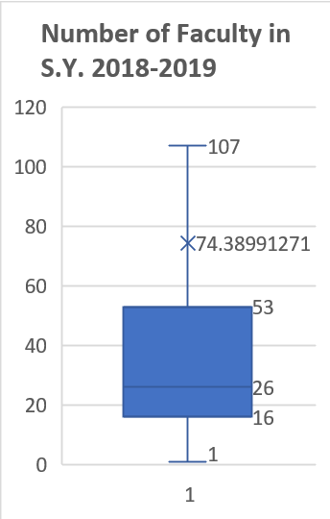

#F8F1EA

Data

**Faculty-to-Student Ratio**

#F8F1EA

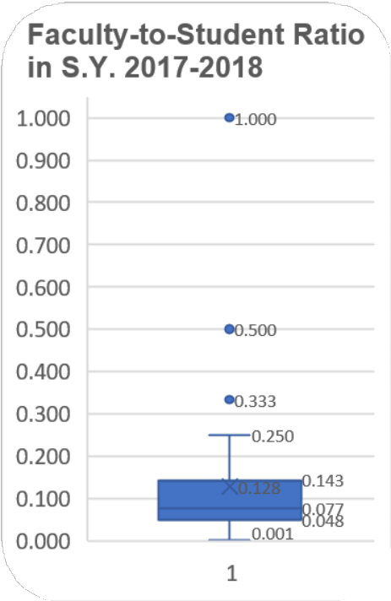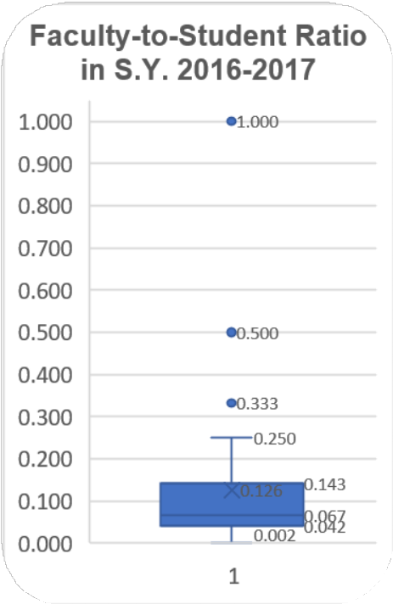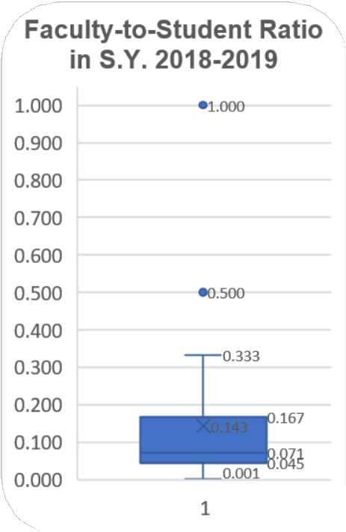

#533220

#F8F1EA

Data

**Progress of the faculty-student ratio within the three school years**

|  |  |
| --- | --- |
|  |  |
|  |  |
|  |  |
|  |  |

**The Standard**

S.Y.

2016-2017

2017-2018

2018-2019

MEDIAN

0.067

0.077

0.071

#F8F1EA

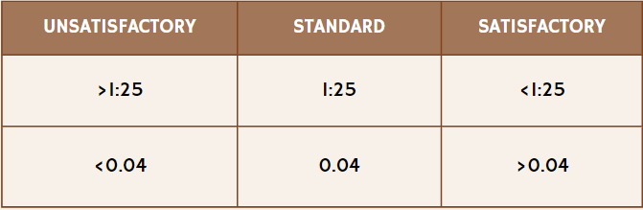#533220

Conclusion

#F8F1EA

***Hiofthliofthts***

***Interpretation***

Declines in the number of faculty and students in Luzon

A sign that may suggest poor leadership/high rates of drop-outs/high rates of unemployment

Faculty-to-student ratio being above 0.04 for the three school years

good standing of the faculty-student ratio

The ideal faculty-student ratio, as stipulated by DepEd Executive Order No. 349, is 1:25 (0.04 in decimal form). These parameters suggest an improvement in the faculty-to-student ratio compared to the standard. In the academic years 2016- 2017, 2017-2018, and 2018-2019, the median faculty-student ratios for colleges in Luzon were 0.067, 0.077, and 0.071, respectively. The analysis concludes that, over these three school years, the overall faculty-student ratio in state and private colleges in Luzon remained relatively satisfactory.

**#533220**

References

#F8F1EA

Public vs Private Colleges: What's The Difference? - Crimson Education US. (n.d.).

Retrieved from Crimson Education:

https://[www.crimsoneducation.org/us/blog/public-vs-private-](http://www.crimsoneducation.org/us/blog/public-vs-private-) colleges/#:~:text=However%2C%20private%20colleges%20tend%20to,other%20ac ademic%20resources%20and%20technology.

Radcliff, B. (2023, September 27). How education and training affect the economy.

Retrieved from Investopedia:

https://[www.investopedia.com/articles/economics/09/education-training-](http://www.investopedia.com/articles/economics/09/education-training-) advantages.asp#:~:text=Why%20Is%20Education%20Considered%20an,greater%2 0output%20and%20economic%20growth.

Salita, D. C. (2023, October 9). Manila | Philippines, Luzon, Population, Map, Climate, &#F8F1EA Facts. Retrieved from Encyclopedia Britannica: https://[www.britannica.com/place/Manila](http://www.britannica.com/place/Manila)

**#533220**